SERILOR®SR – UNIVERSAL USE

Standard resistance screen printing squeegee
serilor®SR squeegee is an all purpose polyurethane blade with good combined resistance to chemicals and abrasion. It was developed to withstand various applications in screen printing. The industry standard SR1 is a universal grade, the ideal choice for non critical abrasive application or when using common screen inks.
serilor®SR screen printing squeegee blades are manufactured with a centrifugation process to avoid bubbles and craters in the material and to bring optimal homogeneity to the compound, even at the core of the material and after grinding. FIMOR exclusive computer controlled casting process guarantees batch to batch consistency.
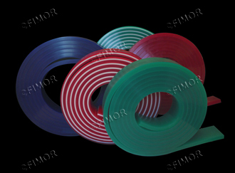
Advantages
- Good resistance to chemicals & abrasion
- Resistance to abrasion
- Sharpens easy
- Color coded for easy identification
- High environment stability
- Individual package and batch
Applications
- Graphics multi-purpose
- Textile printing
- Manual or automatic equipment use

serilor®SR1 MONO LAYER
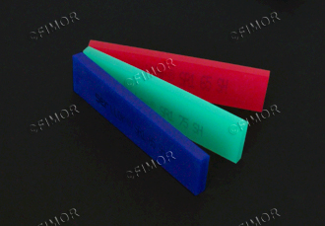
STANDARD REFERENCES :
- soft 65shA red
- medium 75shA green
- hard 85shA blue
60,70,80,90 and other durometers are available as specials
Other colors on request.

serilor®SR3 TRIPLE LAYERS
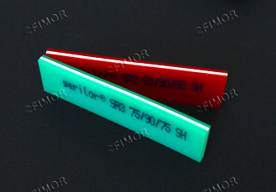
STANDARD COMBINATIONS :
- Triple soft 65/90/65 shA Red/White/Red
- Triple medium 75/90/75 shA Green/White/Green
Recommended when high speed automatic printing equipment is used, serilor®SR3 has a 90shA hard centre layer for support, ideal for fine lines and halftone printing.Using Triple durometer squeegees will extend your squeegee life, help prevent dot gain, and generate immediate savings on ink and other consumable through better control of the squeegee pressure.

Marking: serilor®SR[1 or 3] length X width X thickness Profile hardness [batch N°] MADE IN FRANCE
STANDARD PROFILES :
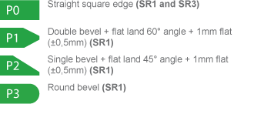
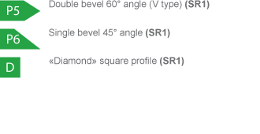
SPECIFICATIONS AND TOLERANCES:
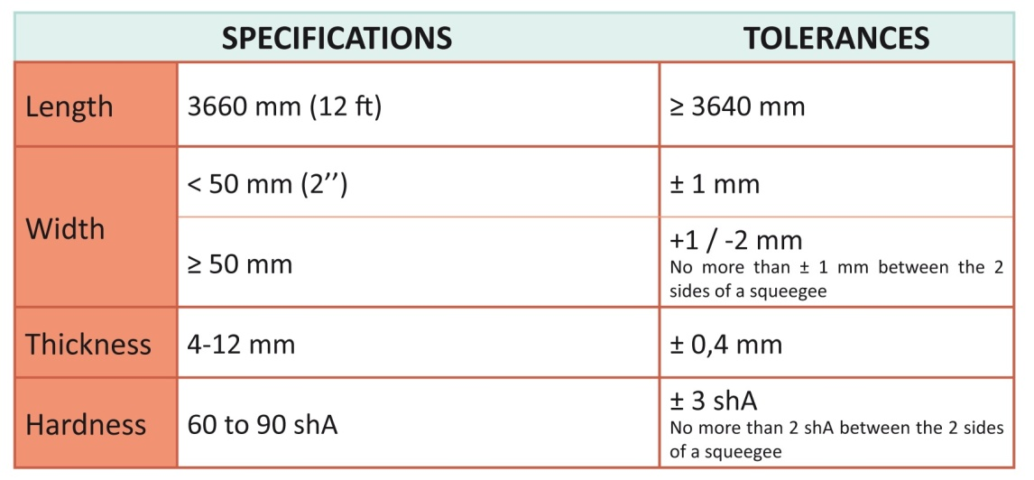
PHYSICAL AND CHEMICAL SPECIFICATIONS (for 75 shA SR1 grade):
