SERILOR®HR – HIGH RESISTANCE

High resistance screen printing squeegees
serilor®HR is a special polyurethane blade with exceptional combined resistance to chemicals and abrasion. It was developed to withstand the toughest applications in screen printing and to have a long shelf life in most environments.
serilor®HR screen printing squeegee blades are manufactured with a centrifugation process to avoid bubbles and craters in the material and to bring optimal homogeneity to the compound, even at the core of the material and after grinding. FIMOR exclusive computer controlled casting process guarantees batch to batch consistency.
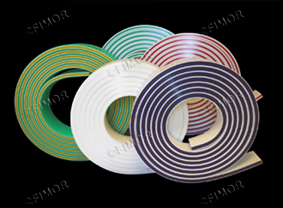
Advantages
- Maximum resistance to chemicals
- Maximum resistance to abrasion
- High environment stability (temperature, humidity)
- Sharpens well
- Individual package protects from light and dust
- Individual batch & reference ink jet marking on blade
- High test inspection for aspect defects
Applications
- Graphics multi-purpose
- Graphics specialties (electronics, industrial etc…)
- Object / Container printing
- Automated textile printing
- Manual or automatic equipment use

serilor®HR1 MONO LAYER
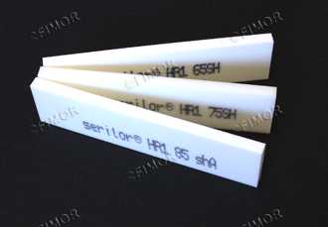
STANDARD REFERENCES :
- soft 65shA white
- medium 75shA white
- hard 85shA white
60,70,80,90 and other durometers are available as specials

serilor®HR3 TRIPLE LAYERS
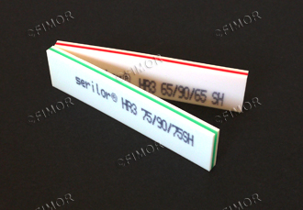
STANDARD REFERENCES :
- Triple soft (65/90/65shA) white/red/white
- Triple medium (75/90/75shA) white/green/white
Recommended when high speed automatic printing equipment is used, serilor®HR3 has a 90shA hard center layer for support, ideal for fine lines and halftone printing.Using triple durometer squeegees will extend your squeegee life, help prevent dot gain, and generate immediate savings on ink and other consumable through better control of the squeegee pressure.

serilor®HR5 ANTI-VIBRATIONS BLADE
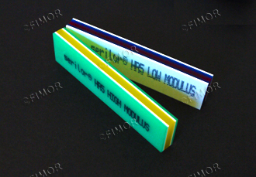
5 layers of soft and hard high resistance polyurethane offer both rigidity for precision printing and softness to absorb vibrations.
Available only in PO profile and graphic dimensions :
50 x 9 mm ; 50 x 9.5 mm ; 50 x 10 mm
serilor®HR5 LM (Low modulus)
5 layers 75 / 85 / 65 / 85 / 75 shA White/Blue/Red/Blue/White
serilor®HR5 HM (High modulus)
5 layers 75 / 95 / 55 / 95 / 75 shA Green/White/Yellow/White/Green

Marking: serilor®HR[1 or 3 or 5] length X width X thickness Profile hardness [batch N°] MADE IN FRANCE

STANDARD PROFILES :
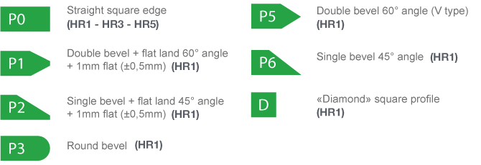
SPECIFICATIONS AND TOLERANCES:
For HR1, HR3 and HR5
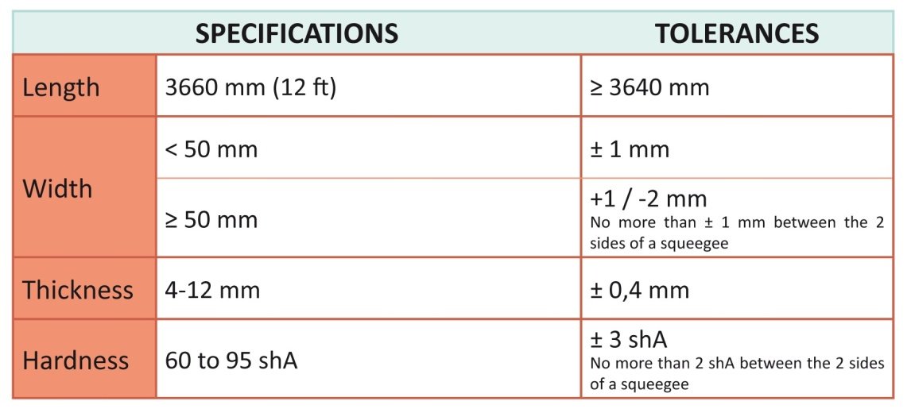
PHYSICAL AND CHEMICAL SPECIFICATIONS (for 75 shA):
For HR1
